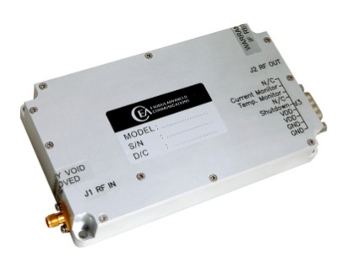
FEATURES
Class AB linear GaN design
Instantaneous wide bandwidth
Suitable for all modulations standards
Built-in protection circuits
High reliability and ruggedness

ELECTRICAL SPECIFICATIONS
Parameter | Specification | Notes
Operating Frequency Range | 1000 - 2000 MHz
Power Output Psat | 35 Watt Min | CW
Output Power @ P1dB | 25 Watt Min
Power Gain | 45 dB Min
Power Gain Flatness | 2.0 dB p-p Max
Input / Output VSWR | >10 dB | Relative to 50 Ohm
2-Tone Intermodulation (IMD) | >30 dBc typ | 35dBm/Tone, Δ = 1MHz
Harmonics | >20 dBc Typ | At rated Pout
Non Harmonics Spurious | >60 dBc
Operating Voltage | 28 VDC Nom
Current Consumption | 5 Amp Max | At rated Pout
Max Input Power Protection | +8 dBm | 10 Sec without damage
Load VSWR Protection | ∞ : 1 | At rated Pout for 1 minute

ENVIRONMENTAL CHARACTERISTICS
Parameter | Specification | Notes
Operating Case Temperature | -20 to +75 °C
Storage Temperature | -40 to +85 °C
Relative Humidity | 5 to 95 % | Non Condensation

MECHANICAL SPECIFICATIONS
Parameter | Specification | Notes
Dimensions | 147 X 69 X 27 mm | Excluding Connectors
Weight | 525 g. | Max Weight
RF Connectors In/Out | SMA female
DC Power / Interface Connector | 9-Pin D-Sub
Cooling | External Heatsink | Forced air required

D-SUB CONNECTOR PIN ASSIGNMENT
Pin | Function | Description
1 | FWD | N/C
2 | REV | N/C
3 | CURRENT SENSOR | I_{D}@20mV/100mA Typ
4 | TEMP SENSOR | V_{T}@10mV/°C + 500mV Typ
5 | SHUTDOWN | TTL
6, 7 | VDD | 28VDC
8, 9 | GND | Ground

OUTLINE DRAWING
